Tableau visualizations

Data analyst: Abraham Cedeño

Date: 11th October 2022

In this document, I will use tableau to answer the S.M.A.R.T questions I created when I started the data analysis.

**Data category 1 - Bike preferences**

**SMART Question one:** “What was the percentual distribution of bike preferences among casual and member riders in the last 12 months?”

**Answer:** I used SQL to query the data I needed and then used tableau to obtain the following visualizations.

**Visualizations for SMART question #1**

**Data category 2 - Trips start day and time**

**SMART Question two:** “On which days of the week have our members used more often the services in the last 12 months?”

**Answer:** I used SQL to query the data I needed and then used tableau to obtain the following visualizations.

**Query for SMART question #2**

SELECT COUNT (day_of_week) AS Trips_per_day_casual_riders, day_of_week, member_casual

FROM `capstone-1-abraham.Trip_data_v3.BikeTrips_todos_v2`

GROUP BY

day_of_week, member_casual

Order by

member_casual,

CASE

WHEN Day_of_week = 'Sunday' THEN 7

WHEN Day_of_week = 'Monday' THEN 1

WHEN Day_of_week = 'Tuesday' THEN 2

WHEN Day_of_week = 'Wednesday' THEN 3

WHEN Day_of_week = 'Thursday' THEN 4

WHEN Day_of_week = 'Friday' THEN 5

WHEN Day_of_week = 'Saturday' THEN 6

END

**SMART Question three:** “At which times of the day have our members used more often the services in the last 12 months?”

**Answer:** I used SQL to query the data I needed and then used tableau to obtain the following visualizations.

**Query for SMART question #3**

SELECT started_time_UTC, COUNT(started_time_UTC) AS Count_of_trips

FROM `capstone-1-abraham.Trip_data_v3.BikeTrips_todos_v2`

GROUP BY started_time_UTC

ORDER BY started_time_UTC

**Visualizations for SMART question #3**

**Data category 3 - Trips end day and time**

**SMART Question four: “**What was the average trip duration of our members in the last 12 months?

**SMART Question five: “**What was the average trip duration of our casual riders in the last 12 months?”

**Answer:** I used SQL to query the data I needed and then used tableau to obtain the following visualizations.

**Query for SMART question #4 and #5**

SELECT ride_length, COUNT(ride_length) AS Conteo_ridelength, member_casual

FROM `capstone-1-abraham.Trip_data_v3.BikeTrips_todos_v2`

GROUP BY ride_length,member_casual

ORDER BY ride_length,member_casual

**Visualizations**

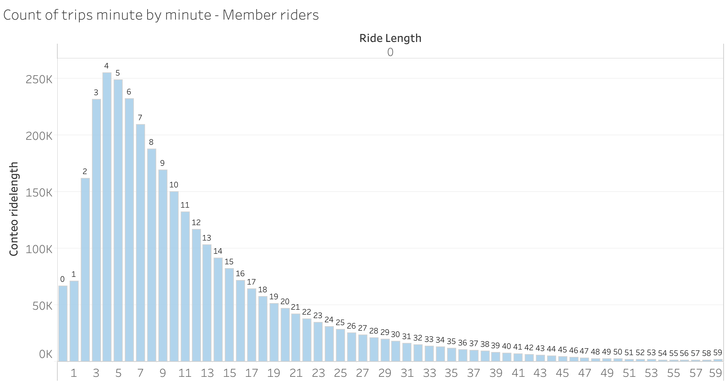

**Data category 4 – Start stations**

**SMART Question six:** “On which stations did the member riders start their rides more often in the last 12 months?”

**Answer:** I used SQL to query the data I needed and then used tableau to obtain the following visualizations.

**Queries for SMART question #6**

**Query #1**

SELECT COUNT (cleaned_start_station_name) AS Number_of_trips, cleaned_start_station_name AS start_station_of_member_riders, member_casual

FROM `capstone-1-abraham.Trip_data_v3.BikeTrips_todos_v2`

WHERE member_casual = 'casual'

GROUP BY

cleaned_start_station_name, member_casual

Order by

COUNT (cleaned_start_station_name) DESC

LIMIT 11

**Query #2**

SELECT COUNT (cleaned_start_station_name) AS Number_of_trips, cleaned_start_station_name AS start_station_of_member_riders, member_casual

FROM `capstone-1-abraham.Trip_data_v3.BikeTrips_todos_v2`

WHERE member_casual = 'member'

GROUP BY

cleaned_start_station_name, member_casual

Order by

COUNT (cleaned_start_station_name) DESC

LIMIT 11

**Visualizations**

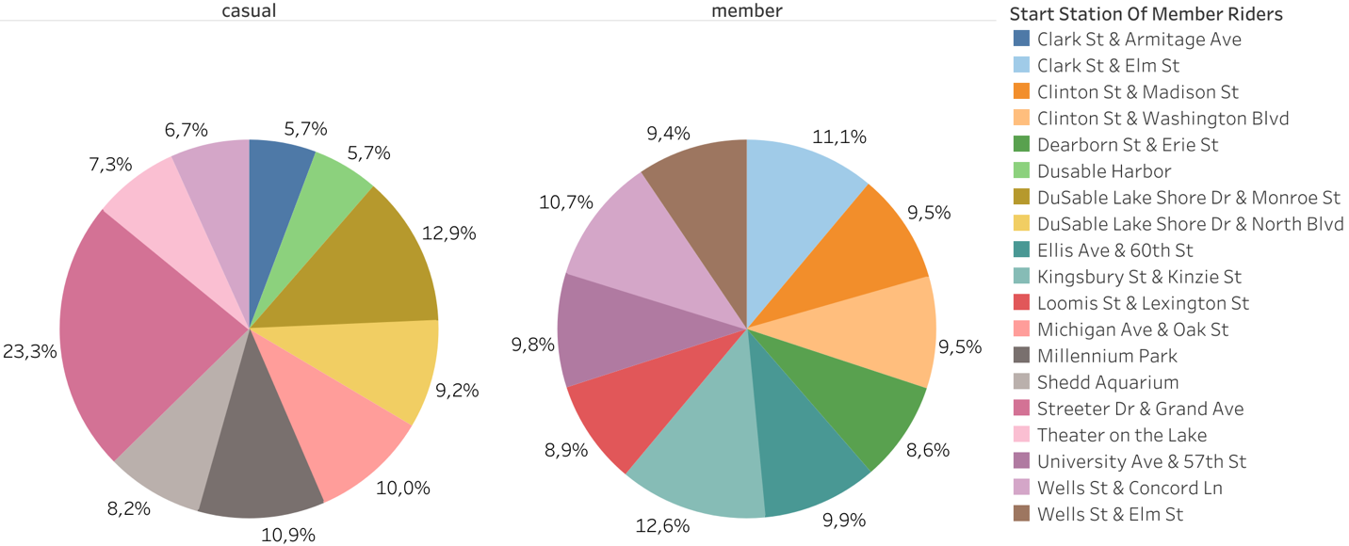

**Data category 5 – End stations**

**SMART Question seven:** “On which stations did the member riders finish their rides more often in the last 12 months?

**Answer:** I used SQL to query the data I needed and then used tableau to obtain the following visualizations.

**Queries for SMART question #7**

**Query #1**

SELECT COUNT (cleaned_end_station_name) AS Number_of_trips, cleaned_end_station_name AS end_station_of_member_riders, member_casual

FROM `capstone-1-abraham.Trip_data_v3.BikeTrips_todos_v2`

WHERE member_casual = 'casual'

GROUP BY

cleaned_end_station_name, member_casual

Order by

COUNT (cleaned_end_station_name) DESC

LIMIT 11

**Query #2**

SELECT COUNT (cleaned_end_station_name) AS Number_of_trips, cleaned_end_station_name AS end_station_of_member_riders, member_casual

FROM `capstone-1-abraham.Trip_data_v3.BikeTrips_todos_v2`

WHERE member_casual = 'member'

GROUP BY

cleaned_end_station_name, member_casual

Order by

COUNT (cleaned_end_station_name) DESC

LIMIT 11

**Visualizations**

**Data category 6 – Start latitude and longitude**

**SMART Question eight:** “What was the distribution of rides starting point per longitude for both casual and member riders in the last 12 months?”

**SMART Question nine:** “What was the distribution of rides starting point per latitude for both casual and member riders in the last 12 months?”

**Answer:** I used SQL to query the data I needed and then used tableau to obtain the following visualizations.

**Queries for SMART question #8 and #9**

**Queries for SMART question #7**

SELECT start_lat AS start_lat, COUNT(start_lat) AS Conteo_geographic_pos, start_lng AS start_lng, member_casual

FROM `capstone-1-abraham.Trip_data_v1.BikeTrips_2021_11_04_v31`

GROUP BY start_lat,start_lng, member_casual

ORDER BY start_lat,start_lng, member_casual

With every single file

**Visualizations**

**Data category 7 – End latitude and longitude**

**SMART Question ten:** “What was the distribution of rides ending point per longitude for both casual and member riders in the last 12 months?”

**SMART Question eleven: “**What was the distribution of rides ending point per latitude for both casual and member riders in the last 12 months?”

**Answer:** I used SQL to query the data I needed and then used tableau to obtain the following visualizations.

**Queries for SMART question #10 and #11**

**Visualizations**

